**The new world order and the era of equality in economics and security**

Author and researcher: Heydar Alkhafaji

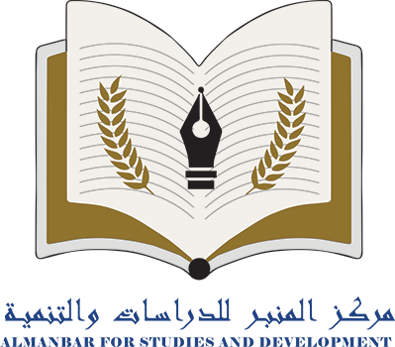

**About us**

Al-Manbar Center for Studies and Sustainable Development is an independent center based in Baghdad. Our main vision is to provide a credible perspective on public and foreign policy issues that primarily concern Iraq and the broader Middle East region. We also address other relevant topics. Our center is dedicated to conducting independent analysis and finding practical solutions to political, economic, social, and cultural issues.

The opinions expressed in the article are the sole responsibility of the author and do not necessarily reflect the views of Al-Manbar Center.

**Copyright reserved for Al-Manbar Center for Studies and Sustainable Development**

[**https://www.almanbar.org**](https://www.almanbar.org)

**info@almanbar.org**

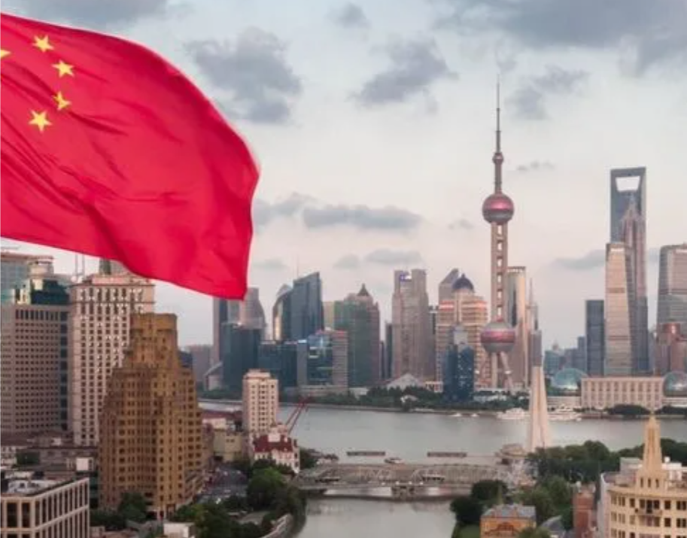

**The new world order and the era of equality in economics and security**

Research and Translation Department

Author and researcher: Heydar Alkhafaji

In economics, the term economic equality refers to the pursuit of a more equitable distribution of wealth and equal opportunities for all in terms of education, health, income and work as well as other aspects of life.[1]

As for the term security in the same context, it refers to striving for stability and security at the national, regional and global levels[2], which requires dealing with various security challenges such as armed conflicts, cyber threats, climate change, and terrorism, amongst others.

Handling these terms and challenges requires a balanced and moderate approach, in accordance with the specific circumstances, priorities and values of each country and society.

In this context, achieving equality in economics and security is the greatest challenge because it requires efforts from all concerned parties, including governments, international organizations, civil society and the private sector. It also requires the adoption of comprehensive economic policies aimed at promoting inclusive and sustainable growth and providing fair opportunities for all, in addition to enhancing international cooperation and global peace and security.

Competition between great powers is one of the major factors affecting international security. In the recent period of contemporary history when the United States and the Soviet Union were known as the two superpowers in the world, we saw that the basis of the political, economic, and security competition between the powers stemmed from ideological differences[3]. With the specter of communism casting its shadow over the world as an idea attractive to the masses, it was natural for the United States of America, as the greatest competitor to the Soviet Union, to be considered the protector of liberalism and for its primary goal to confront the influence of communist ideas in the world.

In other words, it can be argued that in the past, especially during the Cold War, most of the changes that occurred were the result of intellectual conflicts between the two power blocs in the East and West, and in principle, these power blocs were known to represent worldviews evolving from certain ideologies and philosophical ideas. In turn, it extended to the political, economic, and cultural fields and caused the formation of a great competition called the Cold War[4].

But in the post-Cold War era, when the world moved to the era of unipolarity and the consolidation of America as the sole political, military, cultural and economic superpower, the world order faced slow changes, due to the lack of competition between the great powers, and for this reason many developing countries, especially in Asia, saw opportunities to play a role in the regional and international scenes[5].

With the beginning of the new millennium, the world witnessed the emergence of new powers. In the past two decades, this has become one of the most important factors shaping the new world order, with China at the forefront, officially entering a new era in the early 2010s in a challenge from the East that confronts American power on the international scene[6]. Unlike the former Soviet Union, the Chinese have never tried to define themselves as an ideological opponent of America. Today, China is considered one of the most important trading partners in the world for the United States, despite the fierce competition between them.

As the most populous country in the world, China declared full commitment to the dominant international order and presented itself as a developing country seeking a peaceful path to progress to improve the wellbeing of its 1.5 billion people[7]. Over several decades China has followed a path in economic development that has made it the second largest country in the world and the leading economy worldwide[8].

The sovereignty of such states in international spaces has created complications for international security. In the new era, despite the continuation of natural competition between different countries, we are witnessing widespread economic interconnectedness that could impact the competition for power as well. In this case, economic ties between countries are a factor affecting security trends. The new world order can be described as an era of equality in economics and security because with America's acceptance of the central trends of globalization, as the only superpower in the world following the Cold War, the necessary conditions were created for the integration of markets globally. The door was opened to the increasing volume of international capital flows and the intertwining of supply and value chains across the world, ultimately leading to a good transformation of the global economy that cannot be ignored by major international powers.

The strategies of global powers are currently not determined separately from economic issues, and the future of the world offers us a vision in which economic development is meaningfully linked to the development of new technologies such as artificial intelligence, batteries, microchips and renewable energies. In other words, the ability of countries today to access high-tech industries and the best technologies to ensure a strong role in the economic arena is undeniable. This issue means that the world is entering a new order in which actors will have the ability to act on international security issues as long as they have an appropriate share of economic power.

Therefore, it can be said that establishing and strengthening the role of states in global value chains and economic agreements can be as effective as their presence in international security and military agreements. This is an issue that also applies to Iraq as a state, as it has strong geographical capabilities that can provide a historic opportunity to expand its role in economics and security.

Opportunities are not always available and as such, the appropriate role for Iraq must be determined in accordance with the new world order.

Iraq’s various natural and human capabilities can enable it to be a major player in the West Asian region in the era of equality in economics and security. However, if insufficient attention is paid to the importance of maintaining a presence in the global scene, Iraq’s role in the global economy will become ineffective and at risk of exclusion from global markets. The new circumstances could also cause Iraq to have serious security challenges in the long term.

It is necessary for Iraq to define its role through careful monitoring of available opportunities, developing economic, industrial and technological ties with its partners in the region and the world, as well as activating the country’s capabilities and adapting national strategies to international initiatives such as the Chinese Belt and Road Initiative, which seeks to ultimately achieve the objective of forming a global value chain.

References:

1. الحد من عدم المساواة لخلق الفرص <https://www.imf.org/ar/Blogs/Articles/2020/01/07/blog-reduce-inequality-to-create-opportunity>
2. National Security versus Global Security. [https://www.un.org/en/chronicle/article/national-security-versus-global security#:~:text=National%20security%20has%20been%20described,and%20defence%20of%20its%20citizenry](https://www.un.org/en/chronicle/article/national-security-versus-global%20security#:~:text=National%20security%20has%20been%20described,and%20defence%20of%20its%20citizenry)
3. Reasons for the Cold War: Ideological Differences. <https://www.bbc.co.uk/bitesize/guides/z8qnsbk/revision/3>
4. Unipolar versus Unilateral. <https://www.hoover.org/research/unipolar-versus-unilateral>
5. China’s Emergence as a Superpower. <https://www.csis.org/analysis/chinas-emergence-superpower>
6. What is the Population of China? <https://www.theworldcounts.com/populations/countries/china>
7. China’s Emergence as a Superpower: Opportunity or Threat to Global Governance? <https://www.iestork.org/chinas-emergence-as-a-superpower-opportunity-or-threat-to-global-governance/>
8. China’s Economic Growth Mostly Welcomed in Emerging Markets, but Neighbors Wary of Its Influence. <https://www.pewresearch.org/global/2019/12/05/chinas-economic-growth-mostly-welcomed-in-emerging-markets-but-neighbors-wary-of-its-influence/>

1. الحد من عدم المساواة لخلق الفرص <https://www.imf.org/ar/Blogs/Articles/2020/01/07/blog-reduce-inequality-to-create-opportunity>
2. National Security versus Global Security. <https://www.un.org/en/chronicle/article/national-security-versus-global-security#:~:text=National%20security%20has%20been%20described,and%20defence%20of%20its%20citizenry>
3. Reasons for the Cold War: Ideological Differences. <https://www.bbc.co.uk/bitesize/guides/z8qnsbk/revision/3>
4. Ibid
5. Unipolar versus Unilateral. <https://www.hoover.org/research/unipolar-versus-unilateral>
6. China’s Emergence as a Superpower. <https://www.csis.org/analysis/chinas-emergence-superpower>
7. What is the Population of China? <https://www.theworldcounts.com/populations/countries/china>
8. China’s Emergence as a Superpower: Opportunity or Threat to Global Governance? <https://www.iestork.org/chinas-emergence-as-a-superpower-opportunity-or-threat-to-global-governance/> AND China’s Economic Growth Mostly Welcomed in Emerging Markets, but Neighbours Wary of Its Influence. <https://www.pewresearch.org/global/2019/12/05/chinas-economic-growth-mostly-welcomed-in-emerging-markets-but-neighbors-wary-of-its-influence/>